KidsBank
KidsBank collect new and pre-loved items for babies and children - clothes, equipment, school uniform, toys and toiletries. We distribute these items to struggling families across Cheshire and Flintshire. Our mission is to alleviate the impact of childhood poverty by providing practical help as quickly as possible. KidsBank is a registered charity (1190234) who support families in need.

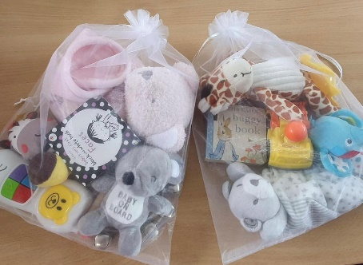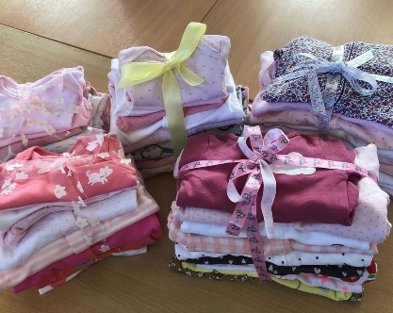

No Postcode without Need
1 in 3
(31%) Children in the UK are living in Poverty.
KidsBank provides support to families with children aged between 0-12 years. Support can be accessed through:
- Self Referral – A family can self-refer for clothing (including school uniform), toiletries and nappies.
- Professional Referral – A professional can complete this form with the family for clothing, toiletries, nappies, as well as other equipment such as feeding equipment, bedding, high chairs, prams, and safety gates.

2023 was our busiest year to date with 1,551 referrals processed across our services. We saw a 27% increase in the number of families accessing our support and there are no postcodes without need. Poverty is on our doorstep and is affecting the children within our schools.

School Uniform
Parents spent on average £287 on primary school uniforms in 2023. At KidsBank we provide non-branded school uniform for primary school children. In 2023, we provided 343 children with uniform they needed.

The government notes, ‘By creating a common identity amongst all pupils, regardless of background, a school uniform can act as a social leveller. It can reduce bullying and peer pressure to wear the latest fashions or other expensive clothes. If, however, the uniform is too expensive it can place an unreasonable burden on families. Furthermore, if a distinction can be made between those who can afford it and those who cannot, this can reduce the benefits of a uniform and has the potential to negatively impact attendance, access and participation, and lead to bullying.’
343
Children provided with uniform from KidsBank in 2023

School uniform represents a significant cost to all parents each year. The School’s Governing Board has an incredible opportunity to positively impact families as they can decide:
- The rules around appearance
- Whether there should be a school uniform policy and if so, what that should be.
- How the uniform should be sourced
Education (Guidance about Costs of School Uniforms) Act 2021
This Act requires School’s Governing Board to have regard to this guidance when developing and implementing their school’s uniform policy.
- Parents should not have to think about the cost of a school uniform when choosing which school(s) to apply for. Therefore, schools need to ensure that their uniform is affordable.
- In considering cost, schools will need to think about the total cost of school uniforms, taking into account all items of uniform or clothing parents will need to provide while their child is at the school.
- Schools should keep the use of branded items to a minimum.
- A school’s uniform policy should be published on the school’s website, be available for all parents, including parents of prospective pupils, and be easily understood.
- Schools should ensure that their uniform supplier arrangements give the highest priority to cost and value for money (including the quality and durability of the garment).
- Single supplier contracts should be avoided unless regular tendering competitions are run where more than one supplier can compete for the contract and where the best value for money is secured. This contract should be retendered at least every 5 years.
- Schools should ensure that second-hand uniforms are available for parents to acquire. Information on second-hand uniforms should be clear for parents of current and prospective pupils and published on the school’s website.
- Schools should engage with parents and pupils when they are developing their school uniform policy.

Supporting Families
Families can access support for school uniform by completing an online form on our website. Their referral is completely confidential and no eligibility criteria to fulfil. Asking for help is incredibly difficult for many of our families and we strive to ensure we support them in a way that protects their dignity and privacy.

School Support
To enable families to access uniform support direct from school, we would recommend the following:
- A separate email address (such as uniform@) is set up to enable parent to access support confidentially.
- The provision of the service to be communicated via school website, and termly newsletters. Examples will be provided.
- Once an email is received by the Administrator, the request is numbered. The referral number, sizes and items needed information is provided to DD.
- DD will then prepare the referral and will mark any bags with the number as the reference. This will be left with reception for collection.
- Family notified that it’s ready for collection.

No-one outside the Administrator is aware of the family who has requested support. Items are prepared for collection from the office, so that the family can collect at a time that is convenient for them and can maintain their privacy.

Second Hand Uniform Availability
The benefits of encouraging the wear of pre-loved uniform include:
- Reducing cost of uniform to families.
- Normalising the wear of pre-loved uniform across the school community. This in turn reducing the potential of there being a distinction between those who can afford new and those who cannot.
- Promoting sustainability, by reducing the number of items that may have ended up in landfill (92m tons of clothing ends up in landfill each year).

To support Pre-Loved Uniform availability, we propose the following:
- DD to liaise with parents to set up a ‘Uniform Team’ at school.
- 2 ‘Donate Days’ per year to be held
  - One during Spring Term (ahead of summer uniform change-over)
  - One at the end of Summer Term (ahead of autumn start date)
- Donations received will be sorted, ironed and bundled by the Uniform Team
  - Only high quality, laundered items will be retained.
  - ‘Too-Loved’ items to be sent to Rags (money received to be added to Uniform fund)
- The Uniform Team will host Pre-Loved Uniform events.
  - Ideally hosted in the school Hall (one ahead of Summer Term and one ahead of Autumn Term
  - The events will allow parents to select bundled items FREE OF CHARGE
  - The events will be open to all parents at the school.

Uniform Fund
A Uniform Fund will be set up, to enable the school to purchase items that are less likely to be donated (e.g. school shoes), or to help reduce uniform costs to families (see below).
- Ragged items
- Donations received from the local community.
- Grant funding (DD to assist with any applicable funding applications)

Branded items & PE Kits
The government guidance on branded items is as follows:
‘Generic items which are widely available (including from low-cost outlets) give parents choice and allows them to control the cost of school uniforms. As such, schools should keep branded items to a minimum and limit their use to low cost or long-lasting items…. The term ‘branded item’ is not just an item with a logo. It is used to describe an item of clothing with distinctive characteristics which make it unique to the school or trust. As a general rule, if an item cannot be purchased at a range of retailers it is likely to be a branded item…. Where a school decides that a branded item is required, they should consider how they can maintain the benefits of a branded item whilst keeping costs low. This may involve using sew or iron on labels or limiting the branded items to longer-lasting items such as ties rather than items that the parent may need to purchase more frequently or in larger quantities such as shirts.’

We would ask Governors to consider the following:
- Whether iron on logos could be provided and branded jumpers/cardigans being made unavailable
- Whether branded bibs (provided by the school), could be used when children are representing the school externally, rather than requiring branded T-Shirts to be worn at sporting events.
- Whether a single, branded item that lasts longer than a single year could be as effective e.g. Pupils can use a satchel throughout their Primary School journey. Could these be provided (utilising funds from a Uniform Fund) to Reception pupils on intake.

Forest School
The government guidance on additional items is as follows:
Schools will need to think about the total cost of their school uniform. It is not enough to consider everyday classroom wear.
Schools should also take into account all items of uniform or clothing parents will need to provide while their child is at the school. This includes items in their PE kit.
No pupil should be discouraged from participating in any aspect of school life, such as interschool competitions, because of the cost of additional uniform requirements.

To participate in Forest School, pupils are asked to provide the following:
- Waterproof coats
- Waterproof Trousers
- Wellies

We would ask Governors to consider the possiblity of providing forest school items if the Uniform Fund was topped up with donations (with involvement from the PTFA and/or external funders to enable this. We recognise, there may be space/storage constraints to consider).

