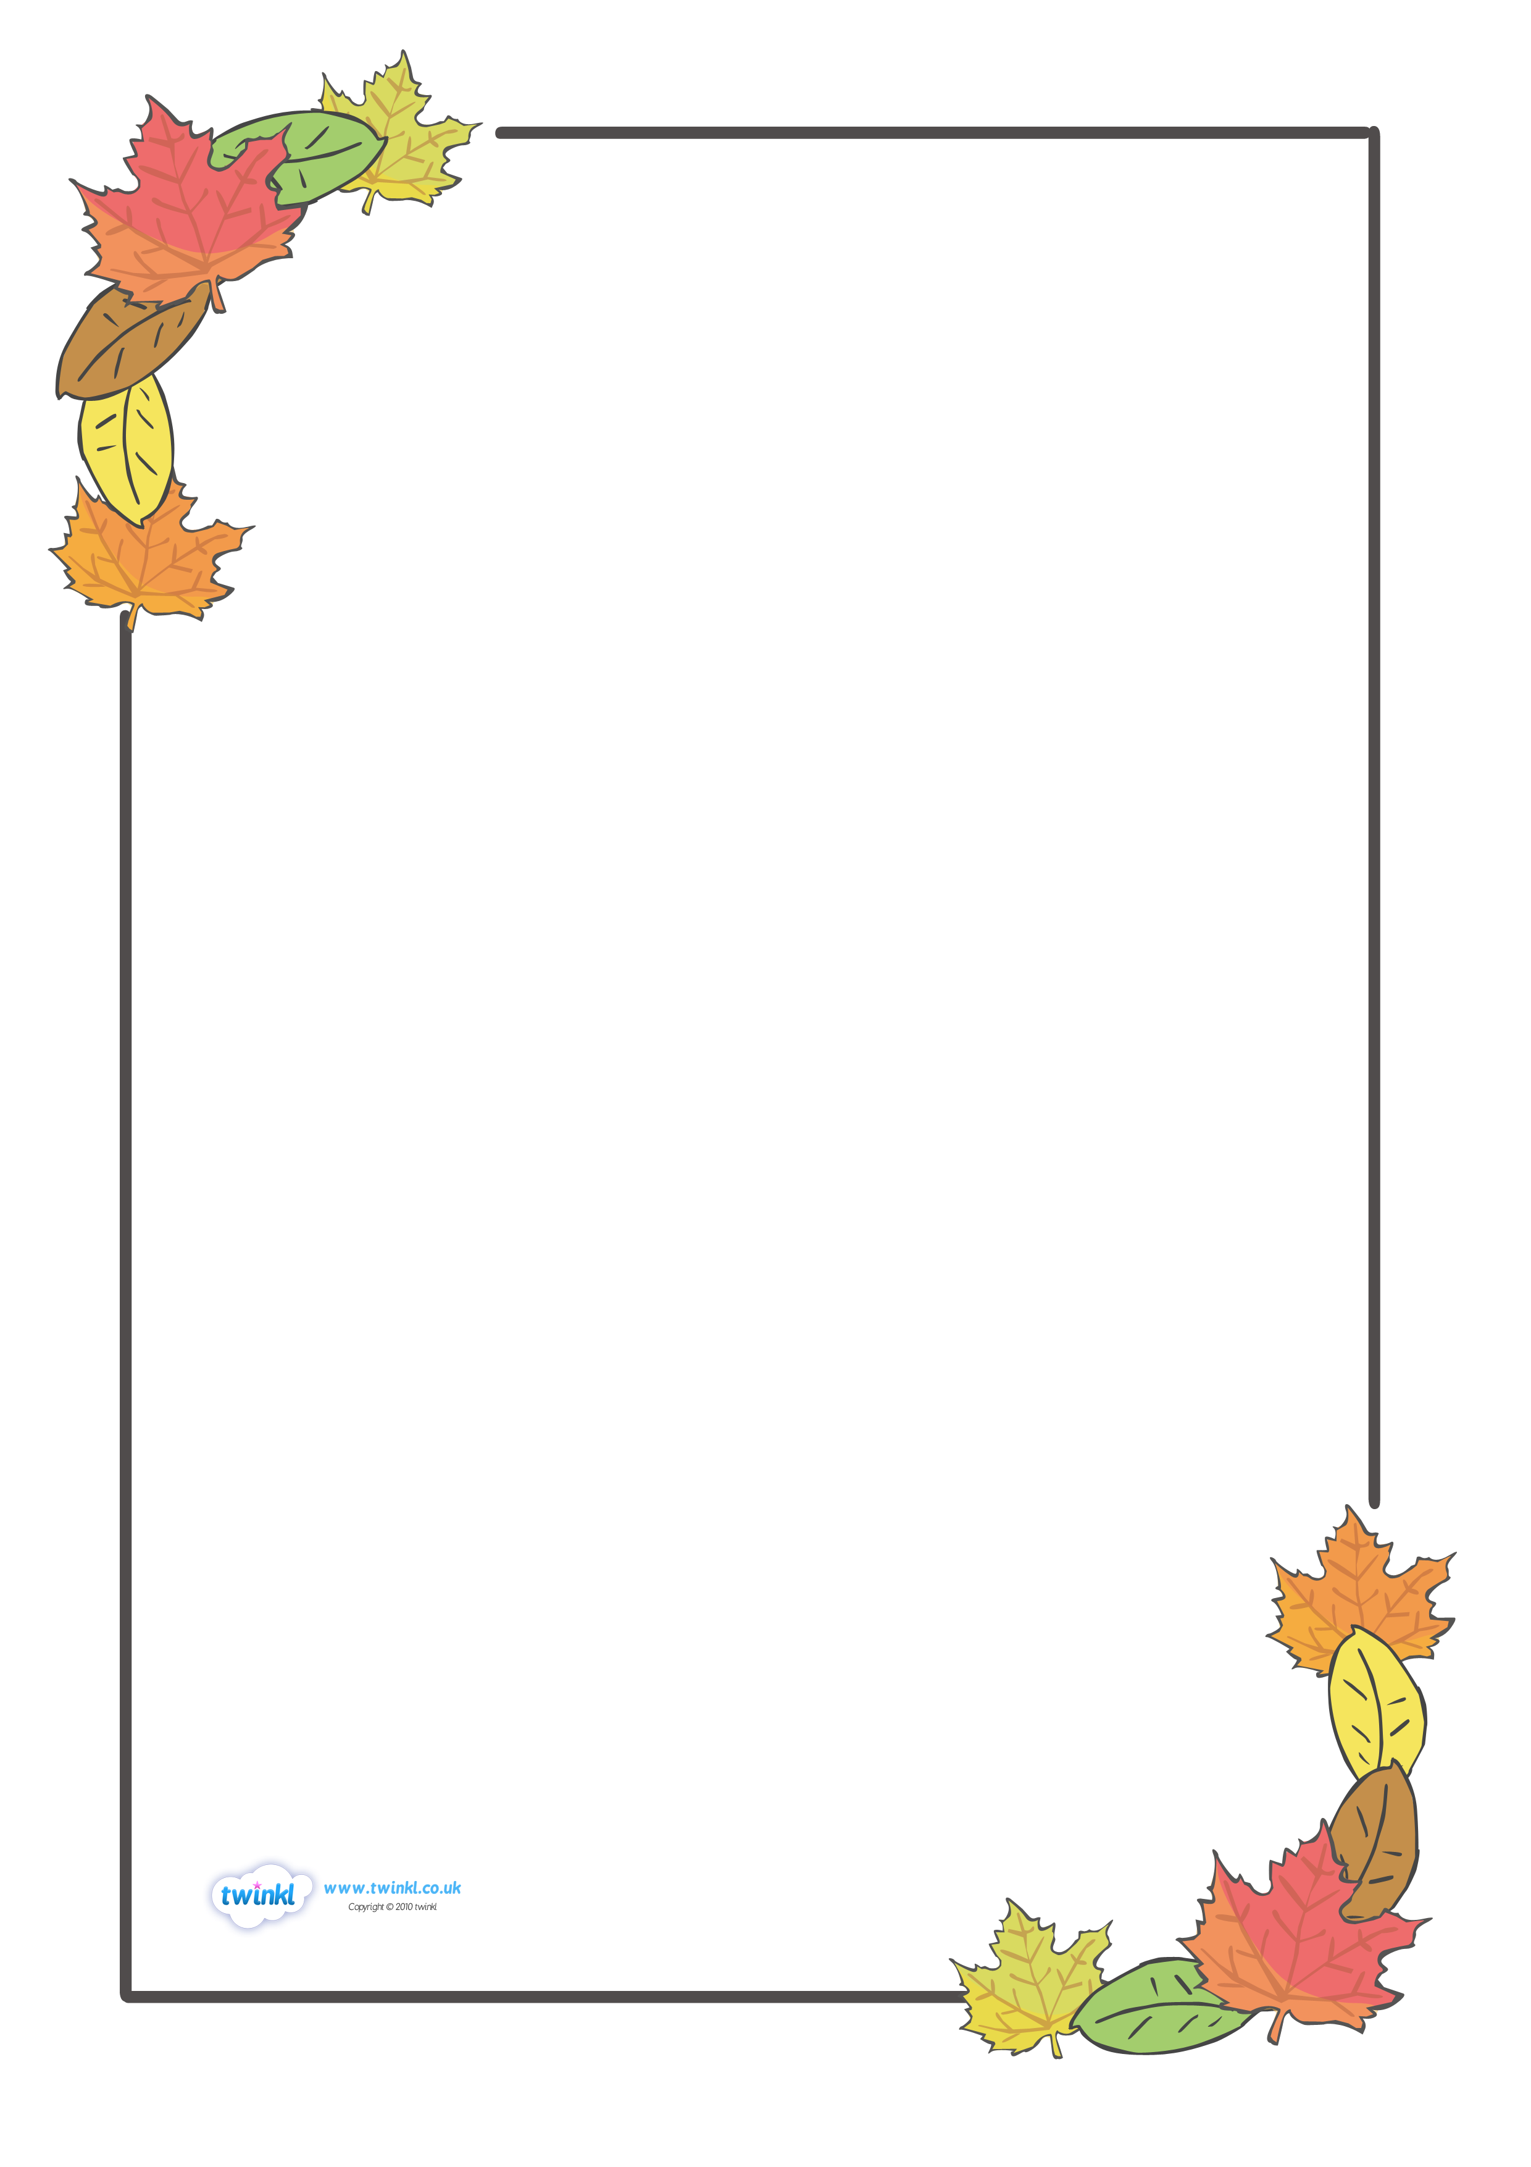

**The Colours of Autumn**

Golden wheat getting cut for food,

straw placed under burnt orange pumpkins,

corn being made into horse feed for the winter,

gold is a colour of autumn.

Tommy Joyner

Red as sunsets fading into the smoke of chimneys,

juicy apples falling onto the damp land,

crispy leaves with shades of scarlet,

red is a colour of autumn.

Zach Hard-Smith

Orange as a huge bumpy pumpkin lying on a prickly layer of golden hay,

an incredible sunset slowly fading into the horizon,

petals of flowers slowly dropping off creating a soft, orange land,

Orange is a colour of autumn.

Lucian Fitton

**LABEL HERE**

**LABEL HERE**